**­­­­­MEEN 305: Project 2 (Individual)**

**Finite Element Analysis of Portal Frame Displacements**

**Jackson Ballew**

**Professor Naveen Thomas**

**Problem:**

We’re given a 7m x 10m frame with applied distributed and point loads, pictured below:

|  |
| --- |
| **Figure 1: Frame** |

Point A is a welded joint, meaning it is constrained against all translation and rotation, and point B is constrained for translation along the Y and Z axes and rotation about the X axis. For the following cross sections, we need to find the displacements of joints C and D. (We take joints C and D to be fixed-welded or rigidly bolted I suppose)

**Table 1: Cross Sections to be Analyzed**

|  |
| --- |
| **Cross Section** |
| W 8x10 |
| W 12x96 |
| Square Tube 7x7x0.25 |
| Pipe XXS 8 |
| St Section 6x17.5 |

Our design criteria are for points C and D to move less than 5mm from their neutral positions.

**Plan:**

1. Create the frame file in SolidWorks. Save this frame file to be copied and used for each analysis.
2. For each cross section:
   * create the weldment-structural member with the appropriate cross section.
   * Set the material property to A36 Steel
   * Create a Study:
     + Specify the appropriate fixtures at A and B
       - A is fixed
       - B has translation in y & z fixed and rotation about x fixed
     + Specify the loading:
       - There is a distributed load like <0, -1000, 0> N/m on the section of the frame from C to D.
       - There is a point load of <190.92, -254.56, 318.19> N at D.
     + Specify the Mesh Control and then generate the mesh
     + Run the study
     + In order to see the displacement of C and D we can either:
       - Use the probe tool to probe the displacement of C and D
       - Under “Results Advisor” in the top bar go-to “List Stress, Displacement, Strain” and the displacement for all nodes can be seen. By selecting a node the node will be highlighted on the part and we can identify which nodes belong to C and D and their respective displacements. Alternatively, the <x, y, z> coordinate of the point can be used to find C and D since these are known based on the given coordinate system of the problem.
   * Record the beam type, orientation, and the displacements of B, C, and D
   * We will also record/collect the cross-sectional area of each beam type
3. We will also need to capture screen shots of the fixtures and loading conditions.
4. We should validate that neglecting the weight of the members in the portal is not going to change our answer significantly. The weight of the vertical members should not since their weight should really just cause axial compression in them, which will result in very small displacements. We are concerned about the bending moment of the weight of CD. So, we will take the cross-sectional areas of each member and multiply this by the density of steel to get the distributed load from the weight of this member. If this load is significantly less than the applied load of 1000N/m (say if it is less than 10%) then we should be fine neglecting it.

**Analysis Process:**

First the frame is sketched:

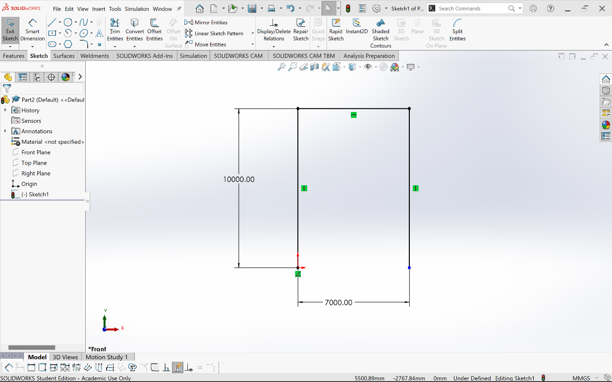

**Figure 2: Frame Sketch**

And then the material is changed to A36 Steel. This file sketch will be used for all of the frames. Then for each beam we create the frame using Weldment-Structural member.

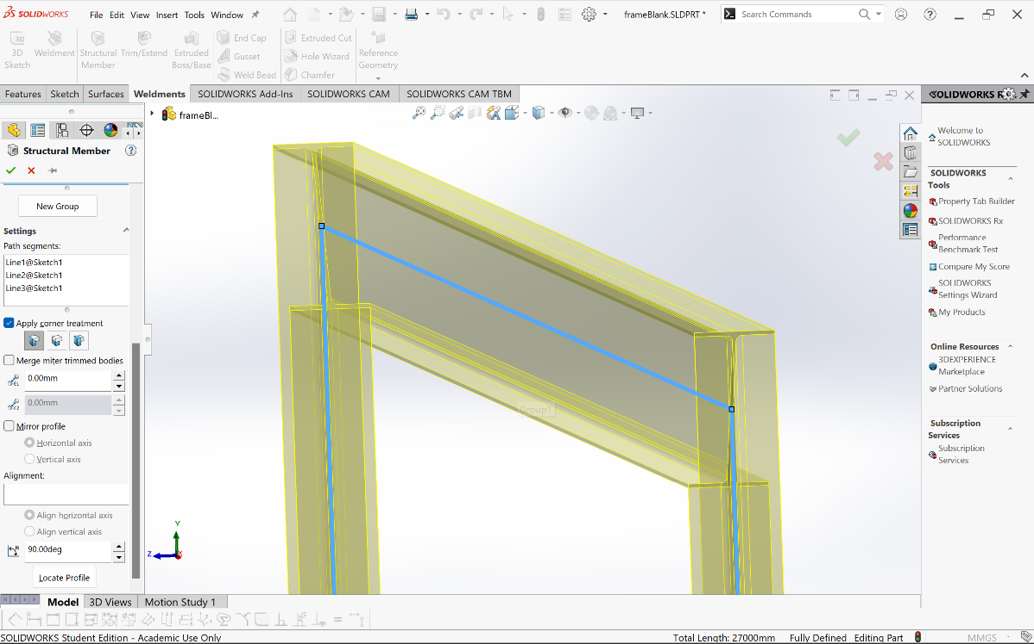

**Figure 3: Sample Weldment, W 8x10, 90deg Rotation**

And then we define our boundary conditions with our fixtures and our loads:

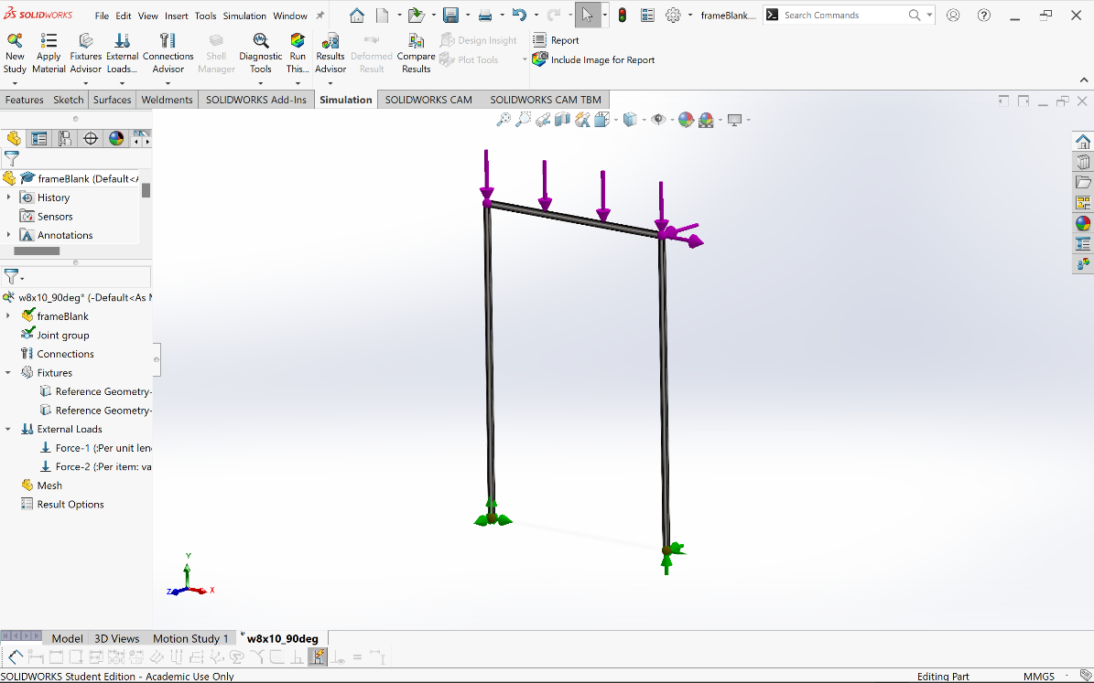

**Figure 4: Sample Loading and Boundary Conditions (Supports)**

Once we do this, we can create the mesh control entity and then generate our mesh. (I plan on using 10 elements for all of the frames, this should be 10 elements per beam so I think I will get 34 nodes per analysis) Once the mesh is generated, we can run the study and we should get something that looks like this:

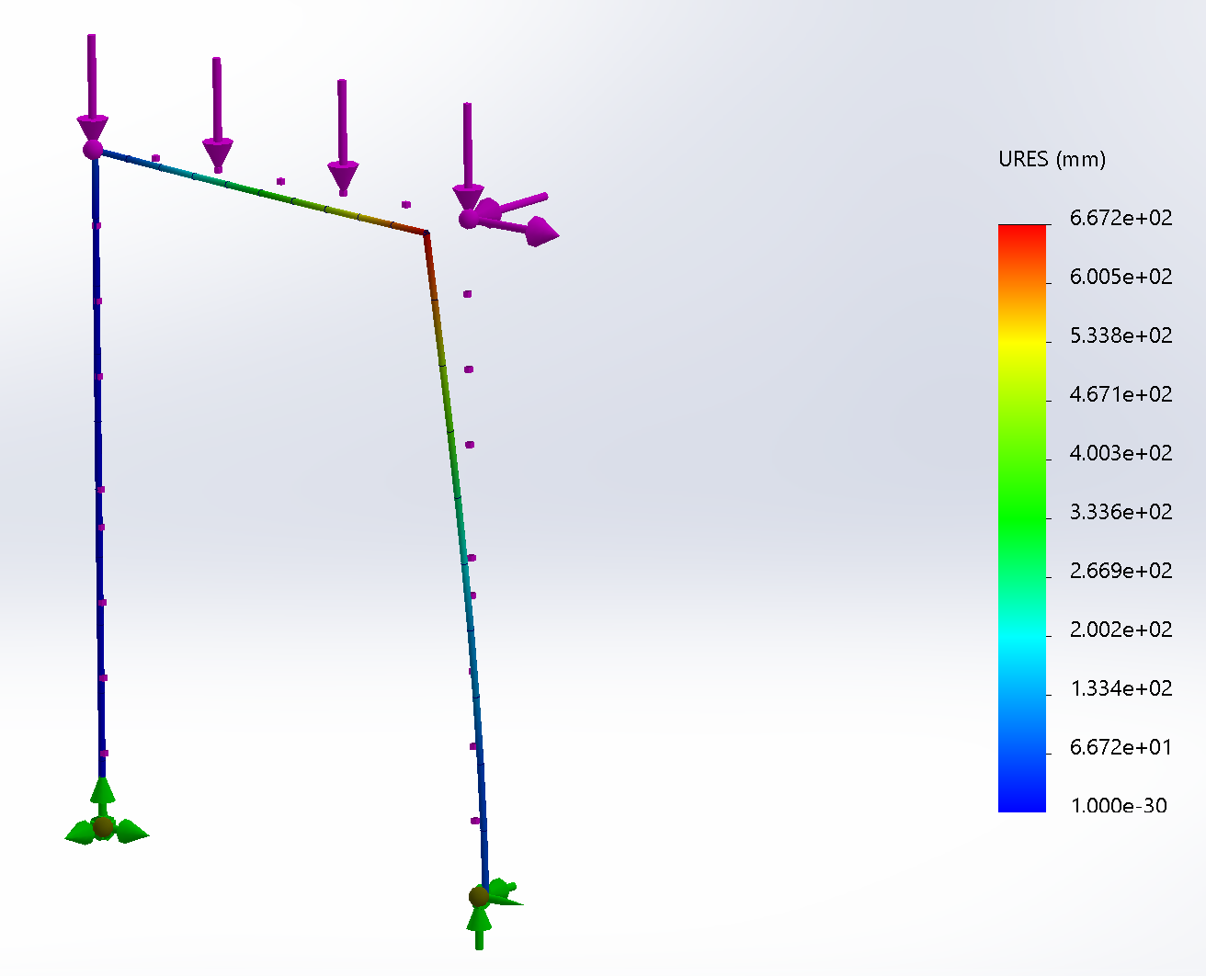

**Figure 5: Sample Study Displacement Output for W 8x10**

And we can find the displacements at C and D:

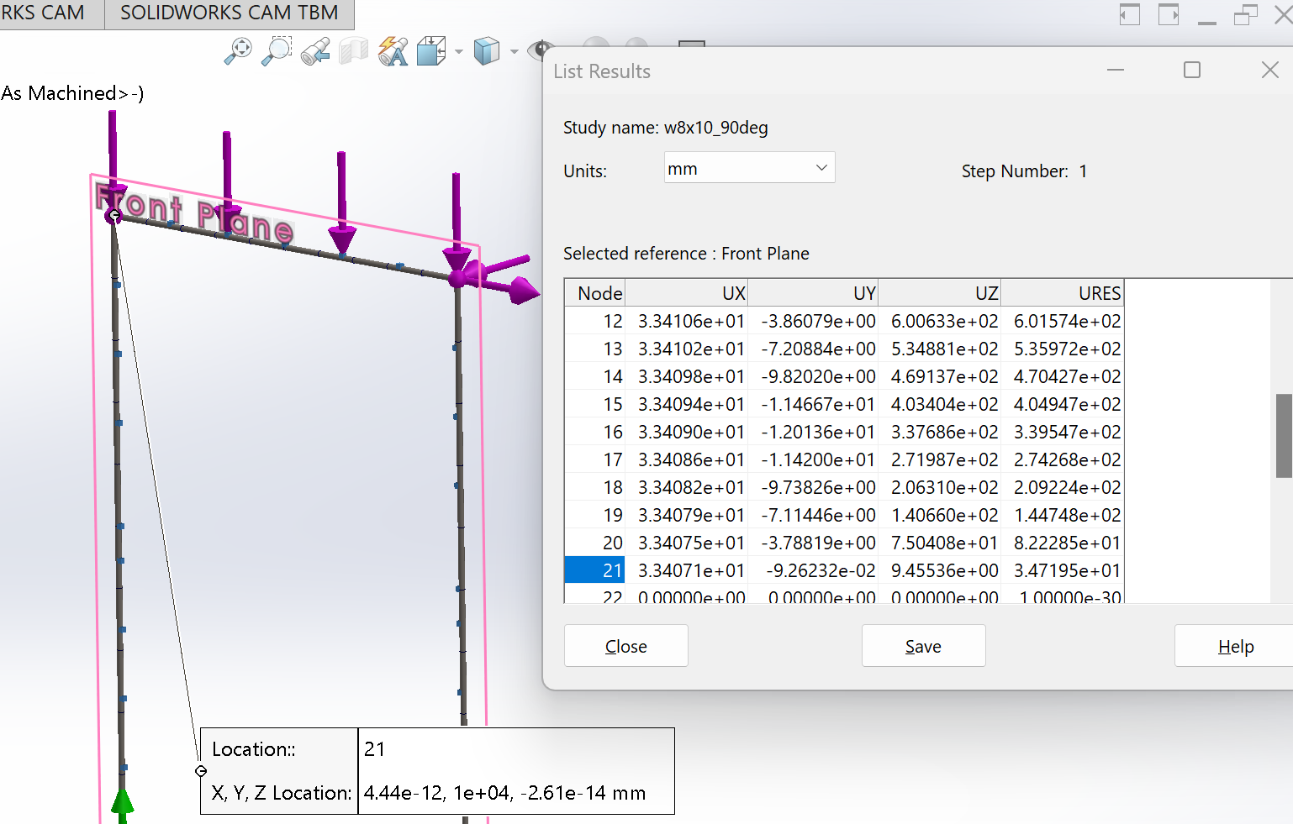

**Figure 6: Sample C Displacement, W 8x10**

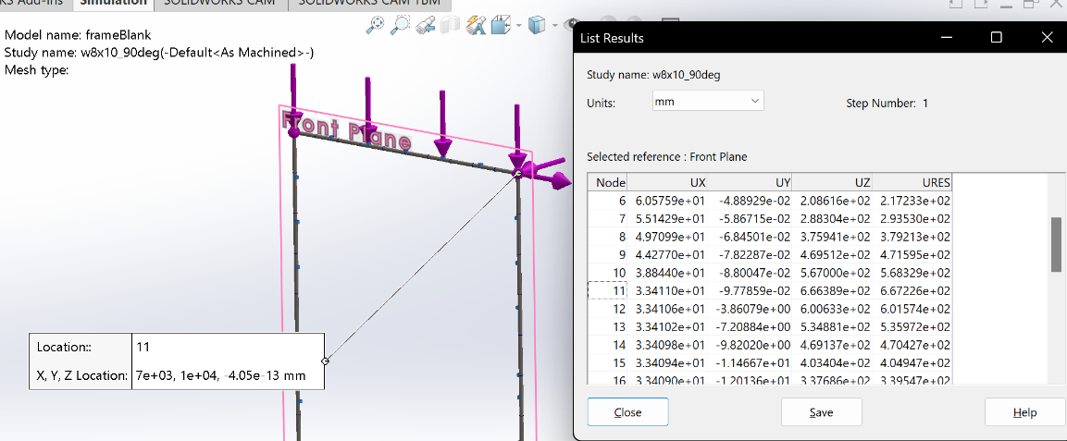

**Figure 7: Sample D Displacement, W 8x10**

Then we just need to record these values and rinse and repeat for the other cross sections. We can analyze different rotations of each to see which satisfy our constraints. Then, we can concern ourselves with potential changes to the frame construction to reduce the displacement of C and D.

**Collected Results and Conclusions:**

**Table 2: Cross Sectional Area and Distributed Load from Weight**

|  |  |  |
| --- | --- | --- |
| **Beam Cross Section** | **Cross Sectional Area (mm^2)** | **Distributed load (N/m)** |
| W 8 x 10 | 1912.42 | 146.3 |
| W 12 x 96 | 18191.92 | 1392 |
| Square Tube  7 x 7 x 0.25 | 4250.99 | 325.3 |
| Pipe XXS 8 | 13744.44 | 1051 |
| St Section 6 x 17.5 | 3321.36 | 254.1 |

Based on these values for the distributed loads for the cross sections, the weight of at least the member CD should not be neglected. The applied load is taken as 1000 N/m and our original criteria was that we should only neglect the weight if it was less than 10% of this, so 100 N/m. The weight per unit length is greater than this for every cross section and the weight per unit length of the two of the cross sections is greater than the applied load. For now, let’s look at the given cross sections and loading without considering self-weight.

**Table 3: Displacements of B, C, and D by Cross Section and Angle**

**(Neglecting Gravity)**

|  |  |  |  |  |
| --- | --- | --- | --- | --- |
| **Beam Cross Section** | **Rotation Angle Degrees** | **Displacement B (mm)** | **Displacement C (mm)** | **Displacement D (mm)** |
| W 8 x 10 | 90 | 86.27 | 33.42 | 600.61 |
| W 8 x 10 | 0 | 1269.1 | 475.29 | 477.08 |
| W 12 x 96 | 90 | 3.198 | 1.2033 | 4.795 |
| W 12 x 96 | 0 | 9.852 | 3.691 | 4.000 |
| Square Tube  7 x 7 x 0.25 | 0 | 53.82 | 21.72 | 26.84 |
| Pipe XXS 8 | 0 | 164.0 | 6.713 | 8.089 |
| St Section 6 x 17.5 | 270 | 169.5 | 65.32 | 257.2 |
| St Section 6 x 17.5 | 90 | 140.46 | 55.46 | 238.6 |
| St Section 6 x 17.5 | 0 | 537.3 | 201.7 | 214.4 |

Based on the FEA results the only cross section considered that would satisfy the design requirements of <5mm displacement for joints C and D was the W 12 x 96 cross section. With the point load of 450N both rotations of the cross section are acceptable (with the original 500N load only the 0 deg cross section was). The deflections of the frames looked like:

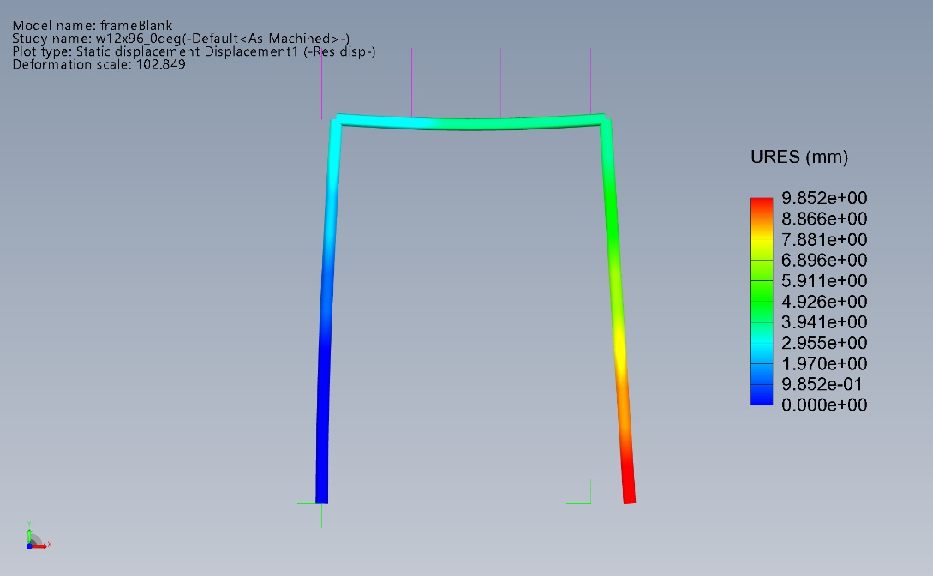

**Figure 8: Deflection of W 12x96 0deg Frame**

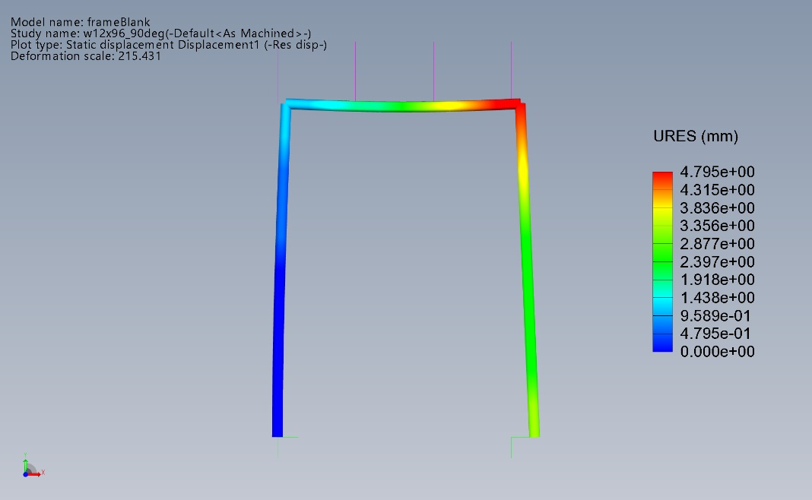

**Figure 9: Deflection of W 12x96 90deg Frame**

At this point we still have multiple concerns:

1. How would adding the self-weight component change our results? We are particularly concerned about whether this would change which beam cross section we should select.
2. All of the frames have some amount of translation in X at B. This is expected since we didn’t constrain this for our analysis. But why wouldn’t we? It seems like the joint at B would be harder to construct than a fixed connection. We clearly can create fixed joints between our portal and the ground since we have one at A. How would fully constraining B change our results?
3. While it’s not something we are concerned about in this course, in reality we would need to be concerned about the cost of these portals. We may want to consider the cost of the different cross sections. Would this, in combination with our two previous points lead us to select a different cross section?
4. Additionally, what about the connections? How does each cross section lend itself to being welded or bolted to another section? How does each cross section lend itself to being mounted to the floor at A or B?

Examples of potential joints:

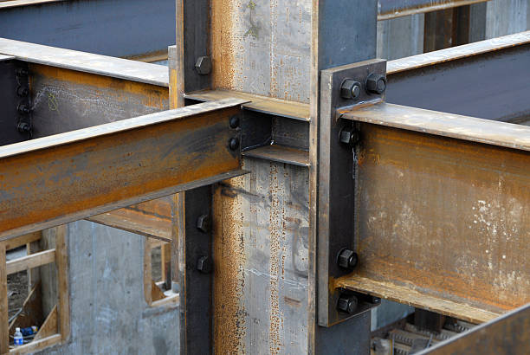

**Figure 10: I-Beam Joint (1)**

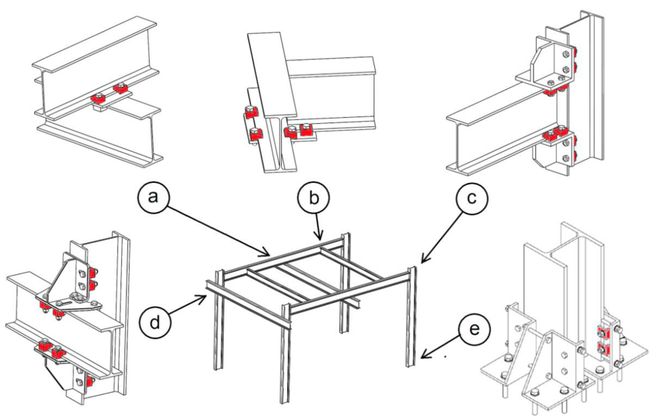

**Figure 11: I-Beam Joints (2)**

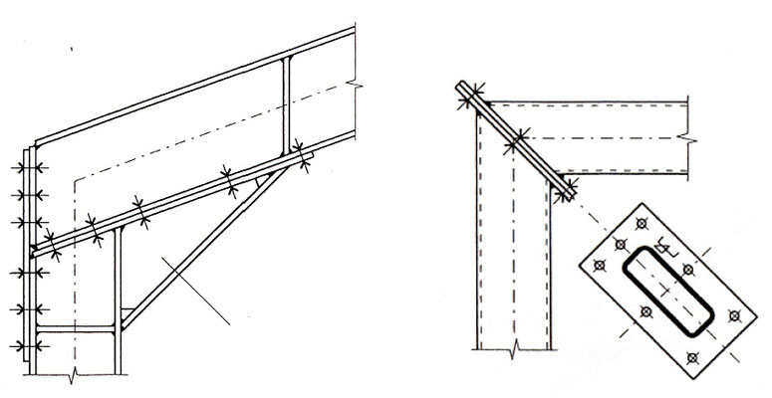

**Figure 12: I-Beam Joints (3)**

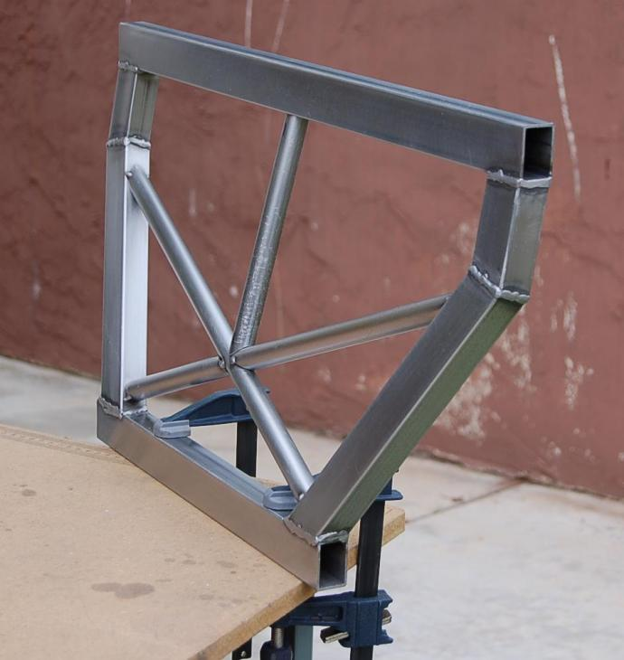

**Figure 13: Square Tube Joint – Welded**

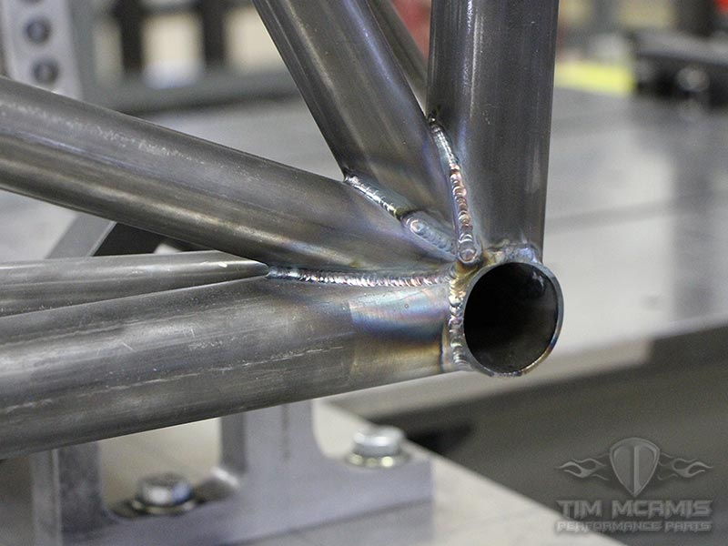

**Figure 14: Pipe Joint – Welded**

We’ll leave concerns 3 and 4 unaddressed for now as they really have a lot more to do with the specific implementation that we are addressing here and we really don’t have enough information to make good conclusions. As for concerns 1 and 2, we can run more tests and see what the output looks like.

**Table 4: Displacements of B, C and D by Cross Section and Angle**

**(Including Gravity)**

|  |  |  |  |  |
| --- | --- | --- | --- | --- |
| **Beam Cross Section** | **Rotation Angle Degrees** | **Displacement B (mm)** | **Displacement C (mm)** | **Displacement D (mm)** |
| W 8 x 10 | 90 | 97.02 | 36.65 | 60.08 |
| W 8 x 10 | 0 | 142.7 | 524.2 | 525.8 |
| W 12 x 96 | 90 | 6.989 | 2.369 | 5.211 |
| W 12 x 96 | 0 | 21.53 | 7.304 | 7.460 |
| Square Tube  7 x 7 x 0.25 | 0 | 68.73 | 26.06 | 30.46 |
| Pipe XXS 8 | 0 | 31.11 | 11.05 | 11.87 |
| St Section 6 x 17.5 | 270 | 206.6 | 76.39 | 260.3 |
| St Section 6 x 17.5 | 90 | 170.6 | 64.46 | 240.9 |
| St Section 6 x 17.5 | 0 | 653.7 | 237.7 | 248.6 |

**Table 5: Displacements of C and D by Cross Section and Angle**

**(Including Gravity, B fixed)**

|  |  |  |  |  |  |
| --- | --- | --- | --- | --- | --- |
| **Beam Cross Section** | **Rotation Angle Degrees** | **Max Stress**  **(MPa)** | **Stress at B (MPa)** | **Displacement C (mm)** | **Displacement D (mm)** |
| W 8 x 10 | 90 | 197 | 197 | 12.40 | 59.66 |
| W 8 x 10 | 0 | 247 | ~0 | 59.94 | 72.80 |
| W 12 x 96 | 90 | 7 | 7 | 0.1974 | 4.614 |
| W 12 x 96 | 0 | 12 | ~0 | 0.4702 | 1.597 |
| Square Tube  7 x 7 x 0.25 | 0 | 22 | ~0 | 9.595 | 16.75 |
| Pipe XXS 8 | 0 | 13 | ~0 | 3.098 | 5.001 |
| St Section 6 x 17.5 | 270 | 128 | 128 | 25.35 | 242.1 |
| St Section 6 x 17.5 | 90 | 123 | 123 | 21.52 | 228.9 |
| St Section 6 x 17.5 | 0 | 148 | ~0 | 25.97 | 76.74 |

*Our textbook lists the yield stress of A36 steel as 250 MPa

**Final Thoughts**

Looking at these results in comparison to the initial analysis, little has changed. Some cross-sections have large changes for a displacement or two but generally the W 12x96 and Pipe XXS 8 cross sections give us the least deflection and lowest stress for all three tests. Looking at the cross-sectional areas shows us why, they have way more material! This means the applied forces are spread out over more material and thus the strains and displacements are lower. The self-load from all this extra material doesn’t appear to impact their performance too much either. I suppose if we did a cost analysis, they may be more expensive, since for equal lengths they require more steel, but we won’t factor this in for this analysis. Changing the boundary conditions, fixing B, did reduce the displacements of C and D but increases the stress and strain in the system since it isn’t free to move. Fixing B also brings the Pipe XXS 8 section into consideration for our portal. An additional item to consider is that the Pipe XXS 8 frame should be stiffer in across all directions when compared to the I-Beam frames since it is rotationally symmetric. This may help it sustain accidental loads that could come from any angle better. And we may, in practice, want to consider the square tubing since it still has small deflections but at a significantly lower cross-sectional area. This means it is probably cheaper than the selected pipe and I-Beam frames. Additionally, it may be significantly easier to join sections of straight tubing than either of the other options.